COMP 1805 B1

Michael Maxwell

101006277

February 11, 2016

2

* 1. Invalid because John doesn’t need a computer to know how to play Minecraft.
  2. Valid because if a student knows how to code in Python then they know Java and C++ so at least one student knows C++.
  3. Valid because if John knew Java then he’d also know C++ and everyone that knows C++ has a job at google.
  4. Invalid because although Bob is not a student because he doesn’t own a laptop, Sue isn’t necessarily a student just because she owns a laptop.
  5. ⌈0.1⌉ = 1  
     ⌈-1.4⌉ = -1  
     ⌈6.3 – ⌈2.7 + ⌈-4.1⌉⌉⌉  
     = ⌈6.3 – ⌈2.7 - 4⌉⌉  
     = ⌈6.3 – ⌈-1.3⌉⌉  
     = ⌈6.3 + 1⌉  
     = 8
  6. ⌈0.5 + 0.5⌉ = 1  
     ⌈0.5⌉ + ⌈0.5⌉ = 2  
     Disproved that ⌈x + y⌉ = ⌈x⌉ + ⌈y⌉
  7. True

1. ...
   1. If a | b and b | c then a | c can be written as: if a | ka and ka | jka then a | jka, where k,j are integers. The first if can be simplified further to 1 | k, which is true for all integers, and ka | jka to 1 | j. So a | jka will be 1 | jk and we know jk is an integer from above so divisibility is transitive.
   2. For the precedent in the implication to be true then b must be a multiple of a and b must also be a multiple of a. The only way for that to occur is for the multiples of each other to be 1, so they would have to be the same value.
   3. ...
   4. ...
   5. ...
2. True
3. It is only possible for a straight line to intersect an exponential function twice. Therefore by finding all the times it changes from the exponential function being larger than the linear function and vice versa we can check if they are equal.  
   exp > lin @ x = -1, exp(-1) != lin(-1), 1.5 != -8  
   exp < lin @ x = 1, exp(1) != lin(1), 3 != 8  
   exp > lin @ x = 6, exp(6) != lin(6), 65 != 48  
   1. {a, b, c} is not an element of S.  
      {a, b, c} is a subset of S.
   2. Cardinality of S is 7.  
      Cardinality of the powerset of S is 128.
   3. {m | April, June, September, November}
   4. {x | 29, 38, 47, 56, 74, 83, 92}
   5. (A – B) ∪ (C – B)  
      (A ∪ C) – B  
      The membership tables are equal therefore it’s valid.

A B C | ( A ∪ C ) – B

---------------------

1 1 1 | 1 1 1 0 1

1 1 0 | 1 1 0 0 1

1 0 1 | 1 1 1 1 0

1 0 0 | 1 1 0 1 0

0 1 1 | 0 1 1 0 1

0 1 0 | 0 0 0 0 1

0 0 1 | 0 1 1 1 0

0 0 0 | 0 0 0 0 0

A B C | ( A - B ) ⋃ ( C - B )

-----------------------------

1 1 1 | 1 0 1 0 1 0 1

1 1 0 | 1 0 1 0 0 0 1

1 0 1 | 1 1 0 1 1 1 0

1 0 0 | 1 1 0 1 0 0 0

0 1 1 | 0 0 1 0 1 0 1

0 1 0 | 0 0 1 0 0 0 1

0 0 1 | 0 0 0 1 1 1 0

0 0 0 | 0 0 0 0 0 0 0

* 1. (A – B) ∪ (A – C)  
       
       
     A – (B ∪ C)  
     The membership tables are not equal therefore it’s invalid.

A B C | A – ( B ∪ C )

---------------------

1 1 1 | 1 0 1 1 1

1 1 0 | 1 0 1 1 0

1 0 1 | 1 0 0 1 1

1 0 0 | 1 1 0 0 0

0 1 1 | 0 0 1 1 1

0 1 0 | 0 0 1 1 0

0 0 1 | 0 0 0 1 1

0 0 0 | 0 0 0 0 0

A B C | ( A - B ) ∪ ( A - C )

-----------------------------

1 1 1 | 1 0 1 0 1 0 1

1 1 0 | 1 0 1 1 1 1 0

1 0 1 | 1 1 0 1 1 0 1

1 0 0 | 1 1 0 1 1 1 0

0 1 1 | 0 0 1 0 0 0 1

0 1 0 | 0 0 1 0 0 0 0

0 0 1 | 0 0 0 0 0 0 1

0 0 0 | 0 0 0 0 0 0 0

* 1. A ∪   
        
     The membership tables are equal therefore it’s valid.

A B C |

-------------------

1 1 1 | 1 0 1 1 1

1 1 0 | 1 0 1 1 0

1 0 1 | 1 0 0 1 1

1 0 0 | 1 0 0 1 0

0 1 1 | 0 0 1 1 1

0 1 0 | 0 0 1 1 0

0 0 1 | 0 1 0 0 1

0 0 0 | 0 1 0 1 0

A B C | A ∪ $\overline{( \overline{ B} ∩ C )}$

-------------------

1 1 1 | 1 1 0 0 1

1 1 0 | 1 1 0 0 0

1 0 1 | 1 1 1 1 1

1 0 0 | 1 1 1 0 0

0 1 1 | 0 1 0 0 1

0 1 0 | 0 1 0 0 0

0 0 1 | 0 0 1 1 1

0 0 0 | 0 1 1 0 0

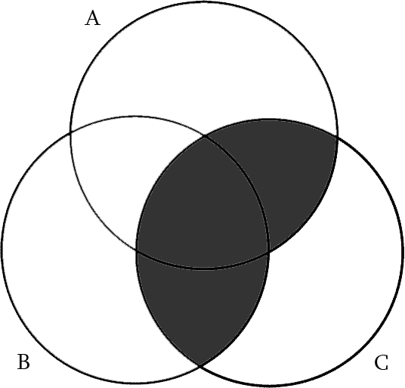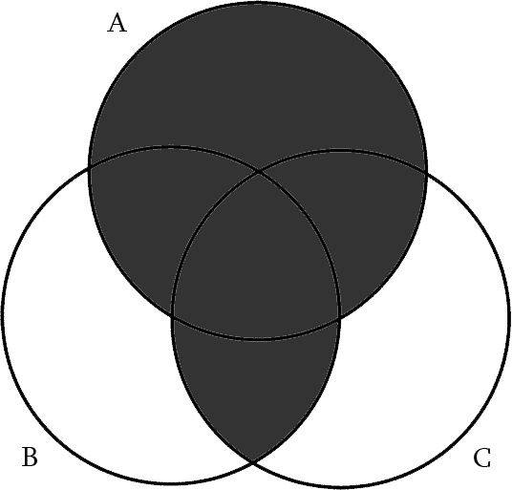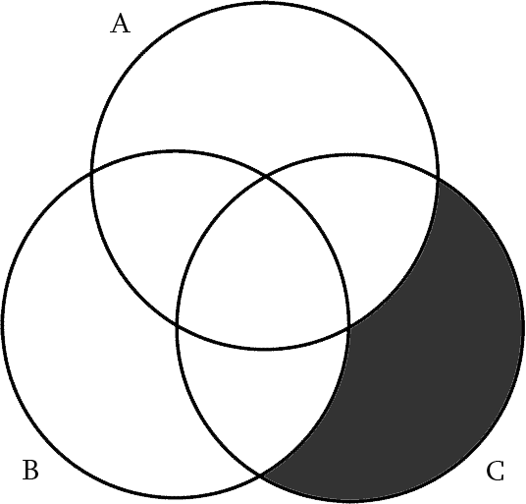

* 1. Ƒ(x) = ⌈2x⌉ is not a bijection because not all y values are mapped to. Only the non-negative real numbers are included in the range.
  2. Ƒ(x) = -7x is a bijection.  
     Ƒ(x)-1 = x/7
  3. Ƒ(x) = -7x3 – 5 is a bijection.  
     Ƒ(x)-1 = ((x + 5) / 7)1/3
  4. Ƒ(x) = 2x + |x| - 1 is a bijection.  
     Ƒ(x)-1 = (x - 1) / 3 and x - 1
  5. Ƒ(x) = x2 – 5 is not a bijection because Ƒ(x) = Ƒ(-x) meaning the y values are mapped to multiple x values.